BIOLOGY PP₂ FORM THREE TERM
THREE 2023
TIME: 2HRS
NAME……………………………………………………………………………………………………ADM NO……………………..
- During an ecological study, form three students encountered three plant species: X, Y and Z. The students recorded the main features of each plant species, as shown below

X: - Leaves with broad lamina and with large air spaces
- Many stomata on the upper epidermis
Y: - Leaves with broad lamina
- Long flexible stems with tendrils
Z: - Large buttress roots
- Pneumatophores

- State the possible habitat of each plant

X...................................................................................................................................... (1 mark)

Y...................................................................................................................................... (1 mark)

Z...................................................................................................................................... (1 mark)

- State the significance of the following:

- Numerous stomata on the upper epidermis in plant X (1 mark)

..............................................................................................................................................................................

..............................................................................................................................................................................

..............................................................................................................................................................................

- Broad leaves in plant Y (1 mark)

..............................................................................................................................................................................

..............................................................................................................................................................................

..............................................................................................................................................................................

- Buttress roots in plant Z (1 mark)

..............................................................................................................................................................................

..............................................................................................................................................................................

..............................................................................................................................................................................

- Give two problems faced by plant X in its habitat (2 marks)

..............................................................................................................................................................................

..............................................................................................................................................................................

..............................................................................................................................................................................

..........................................................................................................................................................................

- The set up below illustrates an experiment to demonstrate a certain biological process, before the addition of the yeast suspension the glucose solution was first boiled and then cooled at 40ºC.
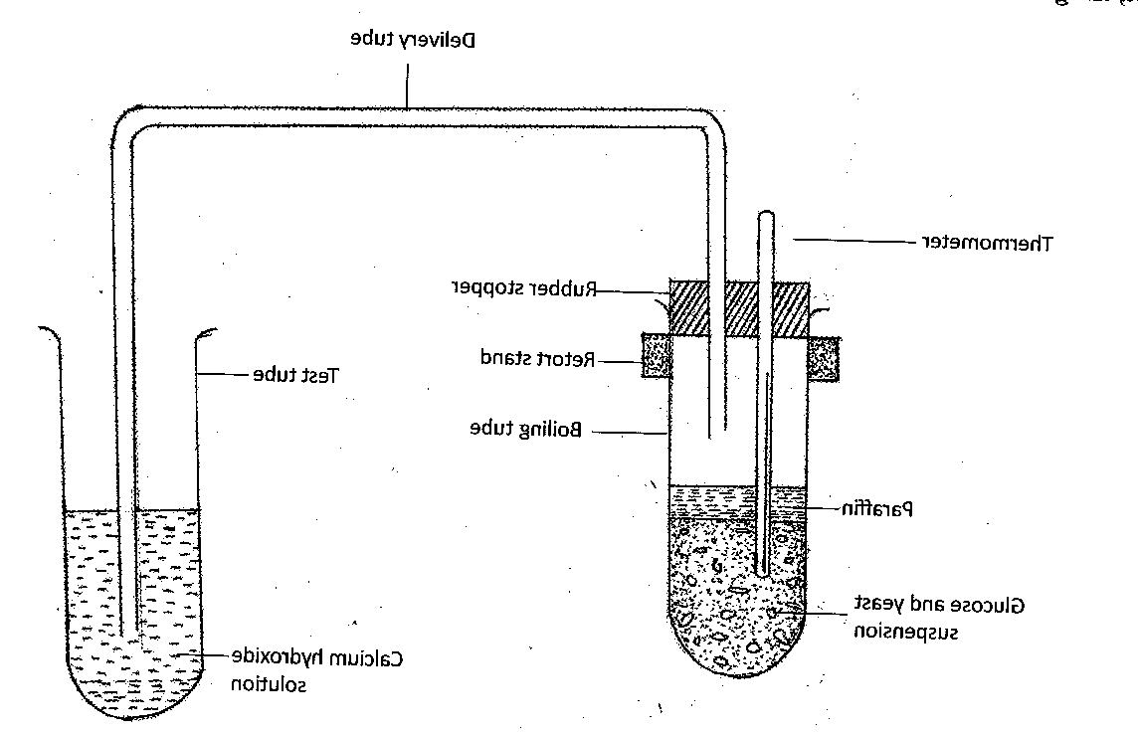
a) What was the aim of the experiment? (1mk)
………………………………………………………………………………………………………………………………………
b) What observations would you make in the tubes a few minutes after the experiment begun (2mks)
………………………………………………………………………………………………………………………………………..
…………………………………………………………………………………………………………………………………………………………………………………………………………………………………………………………………………………..
c) Explain the observations made in (b) above (2mks)
……………………………………………………………………………………………………………………………………………………………………………………………………………………………………………………………………………………
d) Why was glucose solution boiled before cooling at 40ºC (1mk)
………………………………………………………………………………………………………………………………………
e) How can you set up a control experiment for the above (1mk)
…………………………………………………………………………………………………………………………………………
- . Use the photograph of mammalian digestive system and associated organs to answer the questions that follow.
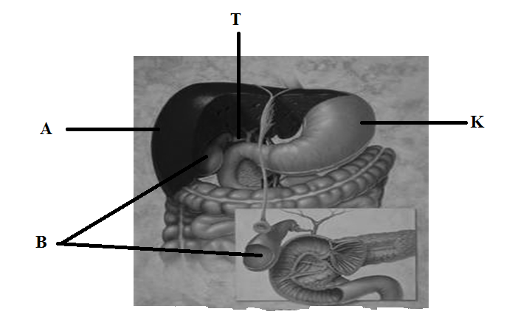

(i) Name the structures marked A, B, K andT. (4marks)
A……………………………………………………………………………………………….B……………………………………………………………………………………………….K……………………………………………………………………………………………….T………………………………………………………………………………………………..
(ii) Name an acid found in the structure labelled K. (1mark)
………………………………………………………………………………………………...
(iii) Name the juice stored in the structure labelled B and give its function. (2marks)
Juice…………………………………………………………………..…………………..
Function………………………………………………………………………………………………………………………………………………………………………………………...…………………………………………………...………………………………………………………………………………………………....................................................…
(iv) Label with letter D part where function named in (iii) above takes place. ( 1 mark)
- The diagram below represents a mature bread mould (Rhizopus)
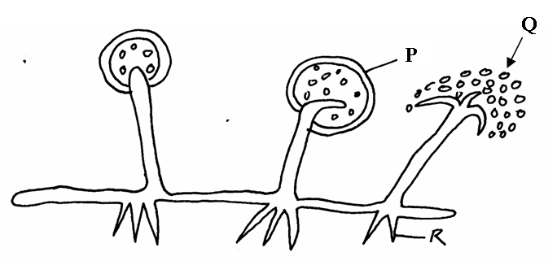
(a) Name the structures P, Q and R (3mks)
…………………………………………………………………………………………………………………………………………………………………………………………………………………………………………………………………………………………………………………………………………………………………………………………………………………………………………………………………………………………………………………………………………………………………………………………………………………..
(b) What is the function of the structure P? (1mk)
…………………………………………………………………………………………………………………………………………………………………………………………………………………………………………………………………………………………………………
(c) State two economic importances of moulds (2mks)
………………………………………………………………………………………………………………………………………………………………………………………………………………………………………………………………………………………………………………………………………………………………………………………………………………………………………………………………
(d) (i) Name the kingdom to which bread mould belong (1mk)
…………………………………………………………………………………………………………………………………………………………………………………………………………………………………………………………………………………………………………
(ii) List down one general characteristic of member of the kingdom named in d (i) above.
....................................................................................................................................................................................................................................................................................................................

- An experiment was set up to investigate a factor in autotrophism in green plants.
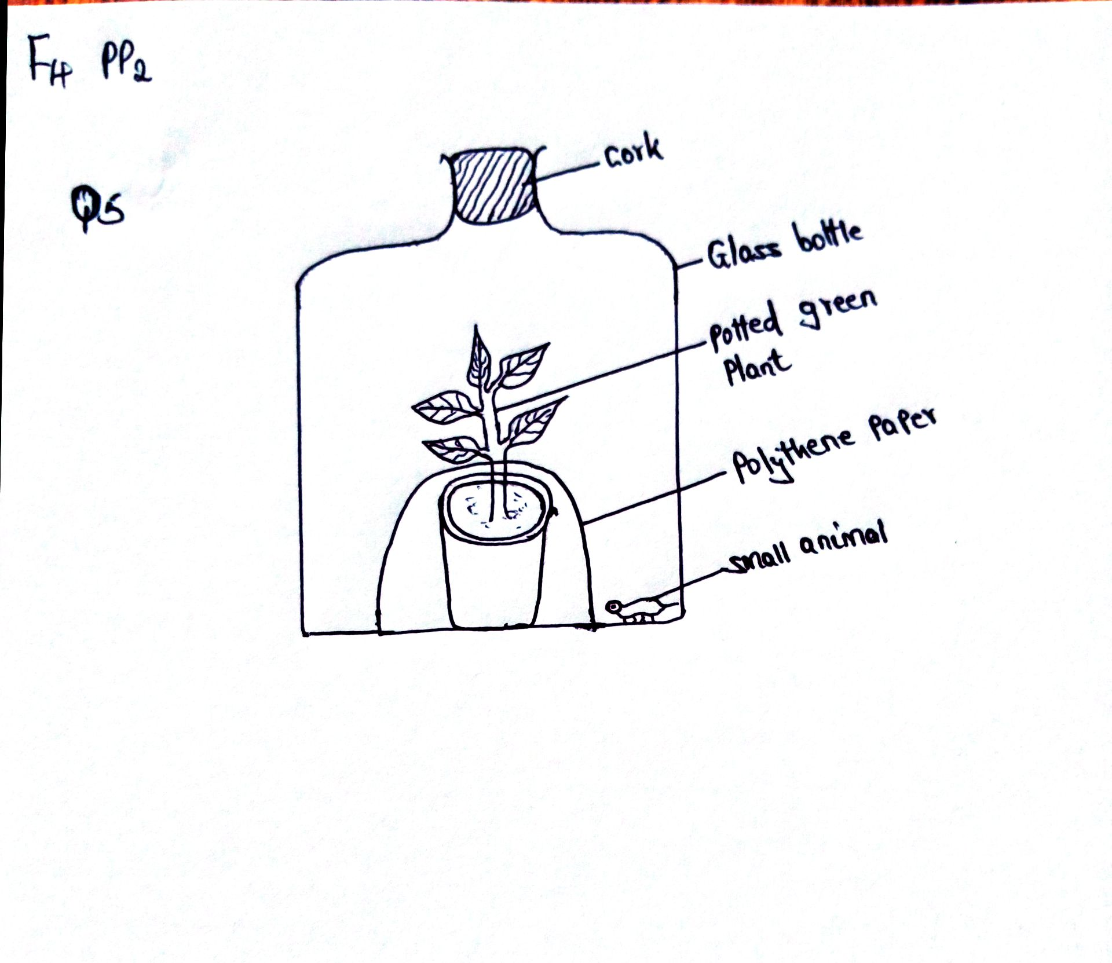

Vaseline was applied at joint between the cork and the mouth of glass bottle and set up was left under sunlight for 6 hours.
- Why was it necessary;
- To apply Vaseline (1mk)
……………………………………………………………………………………………………………………………………..................................................................................................................................................................
- To cover the pot with polythene paper (1mk)
……………………………………………………………………………………………………………………………….........................................................................................................................................................................
- What was the purpose of including the small animals? Give two reasons. (2mks)
……………………………………………………………………………………………………………………………………..................................................................................................................................................................

- i) What would happen to the small animal if the set up was left over night in darkness
(1mk)
……………………………………………………………………………………………………………………………………..........................................................................................................................................................................
……………………………………………………………………………………………………………………………
ii)Account for the answer in b (i) above (1mk)
……………………………………………………………………………………………………………………………
……………………………………………………………………………………………………………………………
- State the respiratory surface of the following organism (2mks)
- Amoeba
………………………………………………………………………………………………………………………………...........................................................................................................................................................
- Fish
…………………………………………………………………………………………………………………
…………………………………………………………………………………………………………………..
SECTION B (40MARKS)
Answer question 6 (compulsory) then choose any between question 7 and 8
- A research was carried out to determine the trend of growth of some boys and girls. Their average mass in kilograms was taken separately for a period of 20 years and tabulated as shown in the table below.
Age | Average mass of boys (kg) | Average mass of girls (kg)
0 | 2.5 | 2.5
2 | 11.5 | 11.5
4 | 15.0 | 16.0
6 | 18.5 | 19.3
8 | 22.1 | 27.1
10 | 25.1 | 27.1
12 | 27.5 | 30.5
14 | 37.0 | 35.5
16 | 44.0 | 44.0
18 | 46.9 | 52.0
20 | 48.5 | 55

On the same axis draw a graph of the average mass of the girls and boys against age (7mks)

- From graph, determine the:
- Mass of boys at the age of 11 years (1mk
………………………………………………………………………………………………………………………………………………………………………………………………………………………………
- Growth rate of girls between ages 13 and 15 (3mks)
………………………………………………………………………………………………………………………………………………………………………………………………………………………………
- Account for the change in the mass of girls during the age stated in ( ii) above (2mks)
……………………………………………………………………………………………………………………………………………………………………………………………………………………………………………………………………………………………………………………………………………….
- Explain the trend observed in the curves for both boys and girls (2mks)
……………………………………………………………………………………………………………………………………………………………………………………………………………………………………………………………………………………………………………………………………………..
- Why do girls above 10 years require intake of food that richer in iron than boys of the same age (2mks)
………………………………………………………………………………………………………………………………………………………………………………………………………………………………………………………………………………………………………………………………………………
- Apart from using average mass to estimate growth in human beings name two other parameters that can be used (2mks)
………………………………………………………………………………………………………………………………………………………………………………………………………………………………………………………………………………………………………………………………………………
- a) Describe the mechanism of inhalation and exhalation in mammals (14mks)

(b) Explain three factors that affect rate of breathing (6mks)

- a) Describe the process of double fertilization in flowering plants. (15 mks)
b) Describe what happens to the various parts of a flower after fertilization. (5 mks)
……………………………………………………………………………………………………………………………………………………………………………………………………………………………………………………………………………………………………………………………………………………………………………………………………………………………………………………………………………………………………………………………………………………………………………………………………………………………………………………………………………………………………………………………………………………………………………………………………………………………………………………………………………………………………………………………………………………………………………………………………………………………………………………………………………………………………………………………………………………………………………………………………………………………………………………………………………………………………………………………………………………………………………………………………………………………………………………………………………………………………………………………………………………………………………………………………………………………………………………………………………………………………………………………………………………………………………………………………………………………………………………………………………………………………………………………………………………………………………………………………………………………………………………………………………………………………………………………………………………………………………………………………………………………………………………………………………………………………………………………………………………………………………………………………………………………………………………………………………………………………………………………………………………………………………………………………………………………………………………………………………………………………………………………………………………………………………………………………………………………………………………………………………………………………………………………………………………………………………………………………………………………………………………………………………………………………………………………………………………………………………………………………………………………………………………………………………………………………………………………………………………………………………………………………………………………………………………………………………………………………………………………………………………………………………………………………………………………………………………………………………………………………………………………………………………………………………………………………………………………………………………………………………………………………………………………………………………………………………………………………………………………………………………………………………………………………………………………………………………………………………………………………………………………………………………………………………………………………………………………………………………………………………………………………………………………………………………………………………………………………………………………………………………………………………………………………………………………………………………………………………………………………………………………………………………………………………………………………………………………………………………………………………………………………………………………………………………………………………………………………………………………………………………………………………………………………………………………………………………………………………………………………………………………………………………………………………………………………………………………………………………………………………………………………………………………………………………………………………………………………………………………………………………………………………………………………………………………………………………………………………………………………………………………………………………………………………………………………………………………………………………………………………………………………………………………………………………………………………………………………………………………………………………………………………………………………………………………………………………………………………………………………………………………………………………………………………………………………………………………………………………………………………………………………………………………………………………………………………………………………………………………………………………………………………………………………………………………………………………………………………………………………………………………………………………………………………………………………………………………………………………………………………………………………………………………………………………………………………………………………………………………………………………………………………………………………………………………………………………………………………………………………………………………………………………………………………………………………………………………………………………………………………………………………………………………………………………………………………………………………………………………………………………………………………………………………………………………………………………………………………………………………………………………………………………………………………………………………………………………………………………………………………………………………………………………………………………………………………………………………………………………………………………………………………………………………………………………………………………………………………………………………………………………………………………………………………………………………………………………………………………………………………………………………………………………………………………………………………………………………………………………………………………………………………………………………………………………………………………………………………………………………………………………………………………………………………………………………………………………………………………………………………………………………………………………………………………………………………………………………………………………………………………………………………………………………………………………………………………………………………………………………………………………………………………………………………………………………………………………………………………………………………………………………………………………………………………………………………………………………………………………………………………………………………………………………………………………………………………………………………………………………………………………………………………………………………………………………………………………………………………………………………………………………………………………………………………………………………………………………………………………………………………………………………………………………………………………………………………………………………………………………………………………………………………………………………………………………………………………………………………………………………………………………………………………………………………………………………………………………………………………………………………………………………………………………………………………………………………………………………………………………………………………………………………………………………………………………………………………………………………………………………………………………………………………………………………………………………………………………………………………………………………………………………………………………………………………………………………………………………………………………………………………………………………………………………………………………………………………………………………………………………………………………………………………………………………………………………………………………………………………………………………………………………………………………………………………………………………………………………………………………………………………………………………………………………………………………………………………………………………………………………………………………………………………………………………………………………………………………………………………………………………………………………………………………………………………………………………………………………………………………………………………………………………………………………………………………………………………………………………………………………………………………………………………………………………………………………………………………………………………………………………………………………………………………………………………………………………………………………………………………………………………………………………………………………………………………………………………………………………………………………………………………………………………………………………………………………………………………………………………………………………………………………………………………………………………………………………………………………………………………………………………………………………………………………………………………………………………………………………………………………………………………………………………………………………………………………………………………………………………………………………………………………………………………………………………………………………………………………………………………………………………………………………………………………………………………………………………………………………………………………………………………………………………………………………………………………………………………………………………………………………………………………………………………………………………………………………………………………………………………………………………………………………………………………………………………………………………………………………………………………………………………………………………………………………………………………………………………………………………………………………………………………………………………………………………………………………………………………………………………………………………………………………………………………………………………………………………………………………………………………………………………………………………………………………………………………………………………………………………………………………………………………………………………………………………………………………………………………………………………………………………………………………………………………………………………………………………………………………………………………………………………………………………………………………………………………………………………………………………………………………………………………………………………………………………………………………………………………………………………………………………………………………………………………………………………………………………………………………………………………………………………………………………………………………………………………………………………………………………………………………………………………………………………………………………………………………………………………………………………………………………………………………………………………………………………………………………………………………………………………………………………………………………………………………………………………………………………………………………………………………………………………………………………………………………………………………………………………………………………………………………………………………………………………………………………………………………………………………………………………………………………………………………………………………………………………………………………………………………………………………………………………………………………………………………………………………………………………………………………………………………………………………………………………………………………………………………………………………………………………………………………………………………………………………………………………………………………………………………………………………………………………………………………………………………………………………………………………………………………………………………………………………………………………………………………………………………………………………………………………………………………………………………………………………………………………………………………………………………………………………………………………………………………………………………………………………………………………………………………………………………………………………………………………………………………………………………………………………………………………………………………………………………………………………………………………………………………………………………………………………………………………………………………………………………………………………………………………………………………………………………………………………………………………………………………………………………………………………………………………………………………………………………………………………………………………………………………………………………………………………………………………………………………………………………………………………………………………………………………………………………………………………………………………………………………………………………………………………………………………………………………………………………………………………………………………………………………………………………………………………………………………………………………………………………………………………………………………………………………………………………………………………………………………………………………………………………………………………………………………………………………………………………………………………………………………………………………………………………………………………………………………………………………………………………………………………………………………………………………………………………………………………………………………………………………………………………………………………………………………………………………………………………………………………………………………………………………………………………………………………………………………………………………………………………………………………………………………………………………………………………………………………………....................................................

